The NFL as a Social Network

Marin Aske
Information Technology
University of Central Florida
ma617209@ucf.edu

Abstract: This research takes the overall league schedule of the National Football League and puts that into a network to analyze. This research was conducted to better understand the connections within the organization with regards to the league schedule and structure. This report will explain the relationship in the NFL of which teams each distinct team play within a 17-game season within the NFL, some history of the league, and what the analysis shows in terms of data driven analytics when applied to this relationship within this network.

Introduction
The NFL as we know it acts as an intermediary between several different sponsored organizations within the United States. What we consider as a source of premium sports entertainment in our society can also be considered a network of like-minded organizations that are sponsored by a governing body in the form of the NFL. In the terms of the network, there are several ways to look at the league as a network. In this report, we will look at it in terms of the NFL sponsoring teams and those teams being scheduled to play each other in a single season. Using the concepts learned in Social Network Analysis, we can conclude some key metrics to analyze how the network will look and behave when applied to the NFL scheduling. To start off, the NFL schedule can be broken down into 17 distinct matchups over an 18-week period. The last remaining week when there isn’t a matchup for each team is considered a bye week and is used for teams to rest up and take a reset in the middle of the season. Some teams get their bye weeks early and others get them later in the season. The selection of a team’s bye week is completely random and based on the rest of the scheduling process. With this in consideration, this network will be focused on the 17 matchups that each team will have during a single 17 game season.

The NFL as an organization has been around since 1970, but the idea and sport of American football has been around since before the league became the prominent professional organization in the United States. In 1920, there was an organization known as the American Professional Football Association that served as the precursor to the National Football League that we know and love today. In 1922, the APFA was renamed as the National Football League and lasted for another 48 years unchanged. In 1970, the National Football League merged with a rival football league, known as the American Football League and this led to the league layout that we see today. As a result of the merger, the NFL was split into two conferences. The two conferences are known as the American Football Conference and the Nation Football Conference. At the end of the season, both conferences hold a tournament, and the winners of each conference’s tournament go on to play in the league’s championship game that we know as the Super Bowl.[1] In the terms of this analysis, we will be looking at an undirected, unweighted, small world network of 32 teams, all with degree of 14. Due to the scheduling and conference layout, the teams play 14 different teams each year, so in regard to this data, we will only be looking at the number of opponents that each team plays and draw our data and conclusions from that.

In section II, we will cover the hypothesis as well as uncover the data collection methods. In section III, we will cover the takeaways from the data, including the graphs, all of the centrality metrics that were discovered when analyzing the data. In section IV, we will cover what happens when we remove a node from the graph for a 1.5 egocentric representation as well as the graphs and metrics from the new data set. Lastly, in section V, we will go over the conclusions, takeaways, and final remarks of the analysis steps for this network.

Hypothesis and Data Collection
For the hypothesis of the analysis of the NFL, we can infer that the schedule being uniform will create some uniformity in the data set. With metrics such as eigenvector, closeness, and page rank seeing the most uniformity, while betweenness may act as the outlier values that shift due to the nature of teams to lay as neighbors for other teams and serve as bridges to connect other teams with teams that they may not play in a season. Due to the nature of this network, we should see an extremely organized distribution within the network that is densely connected. The average degree will be 14 due to the fact that each team will only play 14 distinct opponents every year. The uniformity of this data set will dictate and influence the metrics discussed in section III, and we will get to see how removing a singular node for an egocentric view will affect the data set.

The data collection for this analysis was a tedious and time-consuming process. To gather the data, I went onto ESPN.com to look for the regular schedules of each team. While looking at each team’s schedule, I marked down all 14 opponents that each of the 32 teams will face in the 2025 season and added them to an excel database to create an adjacency matrix to follow along with in the other steps of the data analysis. Each team had to have 14 teams marked down and applied in the adjacency matrix, and then from there each team was added into an excel worksheet to run the data through NodeXL to create the visualizations and record the centrality values. All of the tables with the centrality values were procured using the NodeXL software, and each topology graph was also generated using the NodeXL graph tool after the data sets were run through it.

To understand the network, we need to account for the league distribution. There are 32 nodes on each axis of the matrix, and there are highlighted sections that act as representations of the 4 team cliques that will be formed by each different division in the NFL. This matrix was symmetrical due to the diagonal stretch of values that were 0, representing each team playing themselves in a single season, which we know is impossible.

Graphs and Measurements
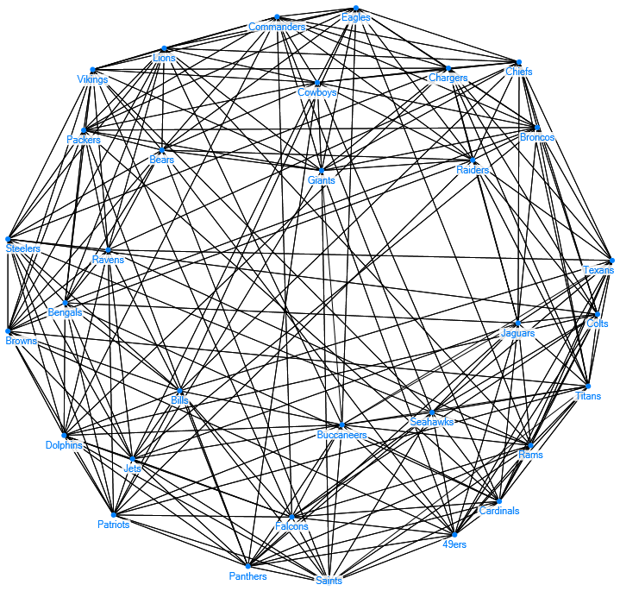

Figure 1: Harel-Koran Fast Multiscale layout of the network topology from NodeXL.

Figure 1 is a representation of the network that we are analyzing in this report. As you can see, the network topology, using the Harel-Korman Fast Multiscale layout in NodeXL, shows how each team is evenly distributed in the network. The central-most nodes represent those that have the highest betweenness centrality due to the fact that they serve as major bridges for each other team. Teams like the Giants and Buccaneers serve as the bridges that connect the rest of their division opponents to other divisions throughout the league. From this network graph, we can discern that each division is represented through the clustered cliques of 4 teams. While other cliques exist, the main ones that we want to pay attention to are just the 4 team cliques that represent the 8 divisions in the NFL.

Degree Centrality

Table 1: The Degree Centrality values of our original data set.

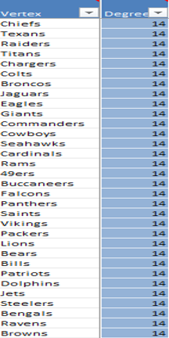
Degree centrality is the measure of the total number of connections that each node has in this network. In Table 1, we see that each team shares the same degree, creating an average degree of 14 for this graph. This is due to the scheduling constraints that the league uses to create the schedule. Each team plays 14 games in a single season, so we have 32 nodes each with degree of 14. Due to this, we see that the data is uniform and there are no nodes that differ. Degree centrality is calculated by counting the number of connections that a singular node has in the network, and the formula for which is shown in Figure 2.

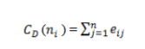

Figure 2: Formula for calculating Degree Centrality

Closeness Centrality

Table 2: The Closeness Centrality values of our original data set.
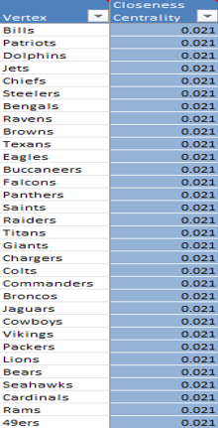
Closeness centrality is the measure of how close one node is to any other node in this network. In table 2, we see that the closeness centrality has the same properties as the degree centrality data. Due to the scheduling, each team shares the same closeness centrality, as all teams are equidistant in this network. There are no teams that differ when it comes to the metric of closeness. We see uniformity in our data set, and this will continue for the remainder of the analysis of the original data set. To calculate closeness centrality, we need to find the inverse of the geodesic distance of each node relative to every other node in the network, and the formula for this can be seen in Figure 3.
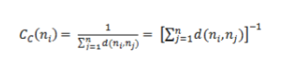
Figure 3: Formula for calculing the Closeness Centrality.

Applying this formula to our data set shows that every single node in our original network has the same closeness centrality, proving that no one team can be considered closer to another team in this network.

Betweenness Centrality

Table 3: Betweenness Centrality values of our original data set.

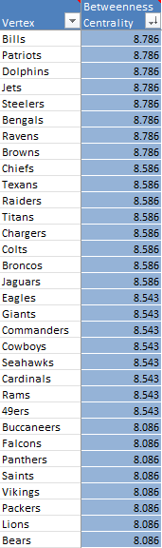
Betweenness Centrality is the measure of how often a node lies along the shortest path between two other nodes. In table 3, we see that the betweenness centrality actually has some ranging values. This can be explained by the fact that some teams serve as bridges between divisions that wouldn’t be connected in any other way. Due to the scheduling, there are 3 random matchups that don’t follow the “conference vs conference” layout. Having a small range of values between 8.786 and 8.086 shows that the network is very uniform, with some teams serving as bridges between divisions, for example the Bills and Patriots will serve as a connector between some major divisions or teams in the network while the Lions and Bears do not.

Betweenness centrality can be calculated using the formula in Figure 4, “G_{iki}” represent the number of geodesic paths linking node I and J that pass-through node K in our network and “G_{ik}” representing the number of geodesic paths linking nodes I and J in our network.

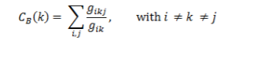
Figure 5: Formula for calculating the Betweenness Centrality of our data set.

Eigenvector Centrality

Table 4: Eigenvector Centrality values of our original data set

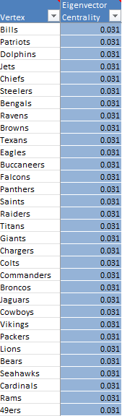

Eigenvector centrality is the measure of a node’s importance to the network while also applying the importance of the node’s neighbors in the network. Due to the uniformity of the degree centrality values, the eigenvector centrality will also be uniform. Table 4 shows the values and their relationship, proving that no single node in this network holds any importance over the rest. This can be explained due to the nature of the NFL schedule and shows that all teams hold the same importance rating within our network. The formula for eigenvector centrality is shown in Figure 6.
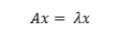

Figure 6: Formula to calculate Eigenvector Centrality of our data set.

Clustering Coefficient

Table 5: Clustering Coefficient of our original data set.

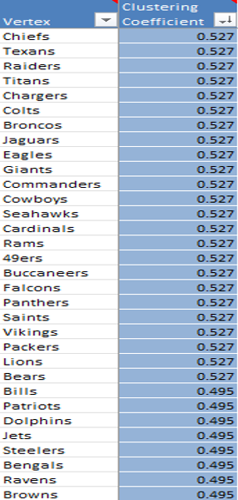

The clustering coefficient measure shows how likely it is that a node’s neighbor also has a connection with a different neighbor. Table 5 shows that the league clusters evenly across the network. Divisions share the same opponents, and with a cyclical scheduling process, the opponents of each team will be shared. Each division will play the other teams within the same division and then will share 8 games with 2 other divisions that cycle in each year. Due to this, we can see that the clustering coefficient will also be fairly uniform. There are some teams with lower values, and that can be attributed to the scheduling process. 2 divisions will always be held in a lower regard for clustering due to the fact that some teams are more centralized than others, and those teams act as the bridges to connect the divisions. Table 5 shows this relationship withing the network, showcasing that the majority of the league is at the same value of 0.527 with 8 teams falling to 0.495.

Page Rank

Table 6: Page Rank measures of our original data set.

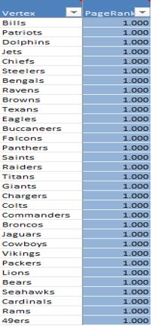

The page rank centrality is the measure of how likely you are to end up on one node in a random walk from one node to another. In this case, again, we can see that the centrality measure for page rank is uniform. Table 6 shows the values for the page rank centrality measure, and we can see that each value is uniform. Again, this is created by the scheduling process that the NFL takes to set their team’s opponents and is driven by the fact that no one node is more important than the other.

1.5 Egocentric of the League
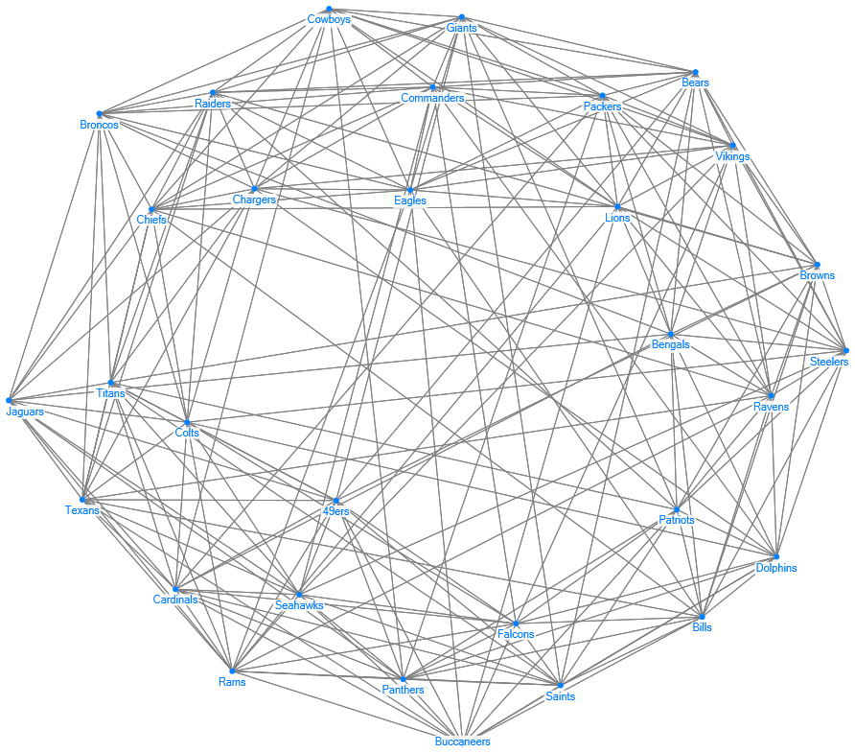
Figure II: Horel-Koman Fast Multiscale layout of the network after the Jets are removed.
For the 1.5 egocentric of this network, we don’t have a specific important node due to the uniformity of the metrics in this network. Usually, we would want to pull the highest eigenvector value, but with the uniform eigenvector values, I have just decided to pull a random team based on the metrics. The team that I found to be the best bet was the New York Jets. I chose them because they were in the group that had the highest betweenness centrality in the original data set. As a result, the Jets were removed from the network, and we will be analyzing the changes of the entire network after they are removed. The way that these metrics are affected by the removal of an ego node is interesting. Changing the degree of a single node can completely shift these metrics into a new data set, even if the centrality values don’t depend on degree. An increase in the degree of some nodes shows that the importance of these nodes is changing as well. Expect to see some significant shifts in the new data set as we explore them in the following sections.

In an egocentric application of a network, you want to extract the ego node. Usually, you would choose the most important or most connected mode, but in this case, we technically don’t have a “most important node.” So, for this application, I decided to choose a team that was withing the highest values on the only metric that wasn’t completely uniform. I used a random number generator to choose between one and eight and pulled number four, which when applied to the betweenness centrality table, equated with the Jets. Removing the Jets allowed for some expected shifts, but seeing where these teams ended up in the final metrics will be an interesting experiment to undertake. The original data set was created using an excel worksheet to manually list all teams 14 times, and then their opponents for each of those games as the connected vertex in the worksheet. Using the original data set, I removed all mentions of the Jets as both a main node and a connected node in the entire data set. That meant removing 28 total vertices from the worksheet. From there, I reproduced the graph with NodeXL to get the topology, as well as recalculated all of the metrics after removing any mention of the Jets as a team.

The topology representation that I have decided to showcase here in this report is the entire network graph without the Jets. We can see significant shifts in the clustering as well as a change in the betweenness of the graph. The two most central teams in the original have shifted down towards the clique or hub that they were more closely associated with, and the center of the graph has become a lot less cluttered with edges running through the middle. This can be explained by the bridges shifting towards their associated groups and the fact that 14 edges were removed from the network graph. In the next sections, we will go through all of the metrics that were derived from the data set and analyze the changes that we could see from the 1.5 egocentric application of our original data set.

Degree Centrality

Table 7: Degree Centrality of the 1.5 Egocentric Data Set.

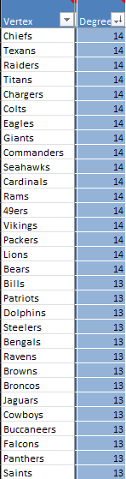

Degree Centrality is the measure of how many connections each node has within the network. As you can see in Table 7, we see that each node that used to have a connection with the Jets now has one less connection, and the nodes that didn’t are the exact same. This metric being affected this uniformly is a testament to how ordered the NFL scheduling system is, considering that the only affected teams are the teams that had a direct connection with the Jets.

Closeness Centrality

Table 8: Closeness Centrality of the 1.5 Egocentric Data Set.

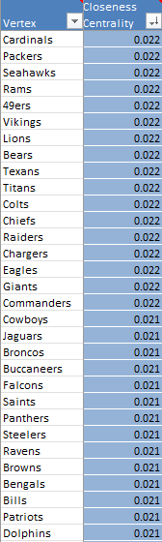
After removing the ego node, we see that the closeness centrality values have shifted, albeit not by a large margin. The teams that saw a connection get taken have stayed at the same value as the original set, but the teams that don’t have seen a .001 increase, showing that these nodes are considered closer to every other node within the network. This is explained by the 17 teams having more connections and being directly connected to more nodes than the other 14 teams that lost a connection.

Betweenness Centrality

Table 9: Betweenness Centrality of the 1.5 Egocentric Data Set.
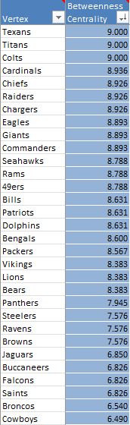

The betweenness centrality shifts significantly after the Jets ego node was removed from the network. Due to the change in total nodes and connections, the range of data values has increased substantially, with more teams acting as bridges for the teams that missed out on a connection to another node as a result of removing the Jets. The higher the value, the more likely that the selected node will act as a bridge, and with the reduction of nodes, the demand for more bridges creates that shift that is represented in Table 9. Analyzing this change was interesting. As we could conclude from the data, just removing one team from the schedule creates a major demand for other teams to pick up where the removed one left off and serve as a bridge for more teams to connect with others within this network. The Texans, Titans and Colts were the ones that stepped up substantially, which was unexpected, but happily welcomed in our data set.

Eigenvector Centrality

Table 10: Eigenvector Centrality of the 1.5 Egocentric Data Set.
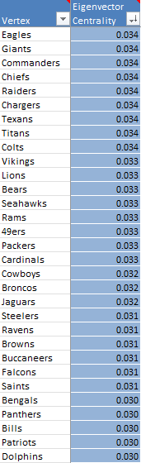

The eigenvector centrality also shifts from the uniformity of the original data set. Instead of each value being the same, we see that some nodes are considered more important than others. This can be explained by the degree centrality shifting the “importance” of a selected node. Since there are now nodes that have higher degree centrality, this accounts for the change that we can see in Table 10. The NFC East is now considered the most important division in the NFL with teams like the Eagles and Giants holding the highest eigenvector values in the 1.5 implementation’s data. Concluding on this metric, I didn’t expect the Giants to stand anywhere close to the top in this data. The Eagles were expected due to the fact that they won the Super Bowl last year and were expected to have the hardest schedule this year. Assuming their relationship within the league, seeing the Cowboys fall of that far was jarring. They are in the same division as the Eagles, Commanders and Giants but somehow fell out of the top 16.

Page Rank

Table 11: Page Rank Centrality of the 1.5 Egocentric Data Set.

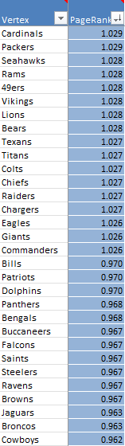

Due to the change in importance of the nodes in our data set, we see a relative shift in our page rank centrality measures as well. Since page rank considers the likelihood of visiting a node randomly when taking a walk through the network, being able to get to more nodes creates a proportional increase in the importance of the nodes. Nodes such as the Cardinals and Packers saw an increase, while nodes such as the Ravens and Browns have seen a sharp decrease in importance, as represented in Table 11. Page rank isn’t really a great metric to use when comparing this data set, specifically since page rank was created to determine or explain how important a website page is. Since this metric is entirely based on the number of links that show up on a webpage, it was hard to analyze what this could truly mean for the data set, but we can still infer that the teams with the highest values will be considered the most important or influential in this network graph.

Clustering Coefficient
Table 12: Clustering Coefficient of the 1.5 Egocentric Data Set.
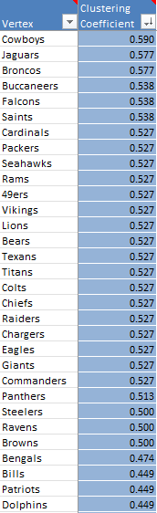

The clustering coefficient measures how tightly a node’s neighbors are connected. In a less uniform network, we will see a range of clustering values. Instead of the uniform values that we had in the original set, the range of values is now more diverse, showcasing how changing the nodes of a network can affect the other metrics. Table 12 shows that the Cowboys are the clear favorite when it comes to clustering, which can be explained by the fact that the Cowboy’s opponents are more likely to play a game with each other than any other team’s opponents.

V. Conclusion and Final Remarks
One of the major takeaways that I was able to draw in this analysis was that leagues rely on order in their ranks. A sports organization needs to make sure they are running smoothly and in order to avoid conflicts or issues in their day-to-day operations. Before this analysis, I wouldn’t have even realized the work that it takes to make sure these operations go smoothly, and as a result now hold these organizations in higher regard. As we can see, a single change in the system can lead to massive changes in the flow and order of the league, and trying to mitigate those changes is paramount in protecting the integrity of the league. Considering how these schedules are set up, especially for the NFL, I was honestly shocked that the league metrics were so uniform. I understand that there was always some idea of uniformity, it is eye opening to see just how well they have organized this system to try and make these schedules as fair as possible. Also, seeing how just removing a singular team from the league created massive shifts was interesting as well. Removing the Jets node to analyze the graph without the ego node, we saw that some teams shifted higher in the hierarchy of our data set, while others sank well below where they were located in the original set. This shift just goes to show how important order is in the scheduling process of the NFL, and in theory, every other mainstream professional sports organization as well.

References
[1] National Football League (NFL) | History, Teams, & Facts | Britannica, www.britannica.com/topic/National-Football-League. Accessed 19 Nov. 2025.

[2] “NFL Schedule - 2025 Season.” ESPN, ESPN Internet Ventures, www.espn.com/nfl/schedule. Accessed 19 Nov. 2025.

